## Bus System User Manual

This user manual will be straightforward and to the point telling you exactly the user needs to do to use the system. It shall not be anything complicated.

User Login

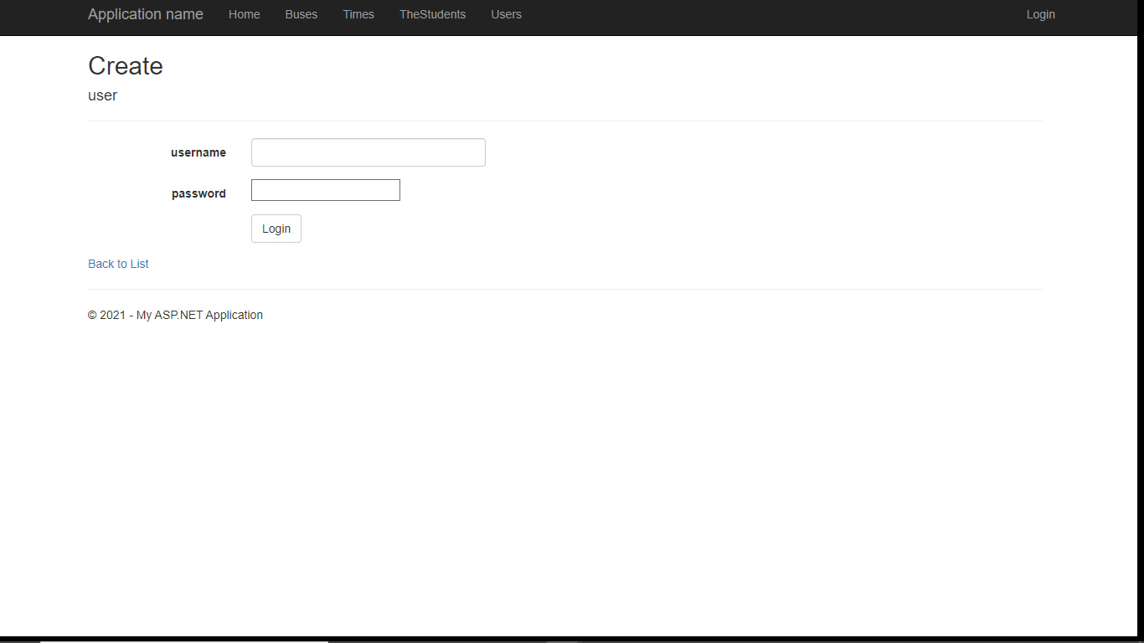

On this form the user will insert their created username and password then press ‘Login’. In which case the user will be redirected to the home page.

## Inserting New Data

The process for inserting data will always be the same. Just cycle through any of the tabs on-screen. Then once there simply click on where it says ‘Create New’ and then you will be redirected to a tab where you can enter new data.

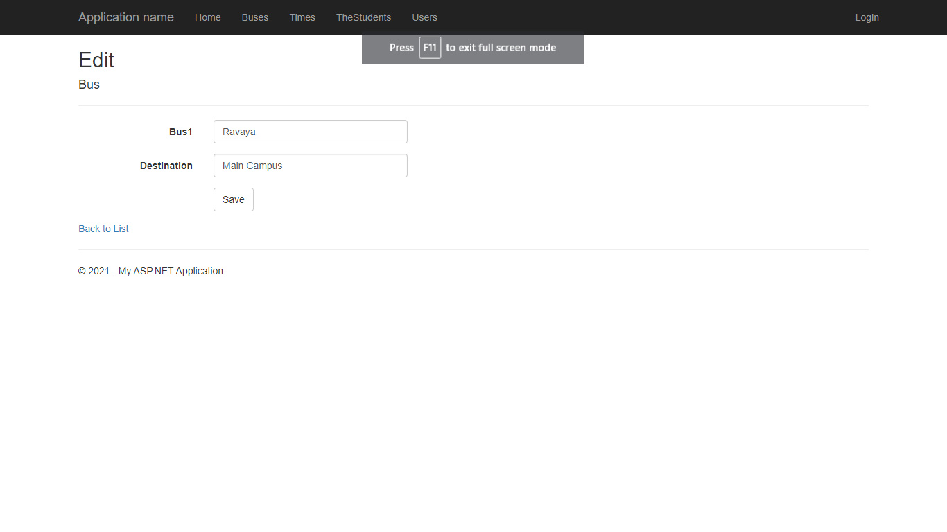

In this tab all the bus driver needs to do is to enter the name of the Bus and where the bus will go for the day. After all the relevant data has been entered click on ‘Save’.

# Student Tab

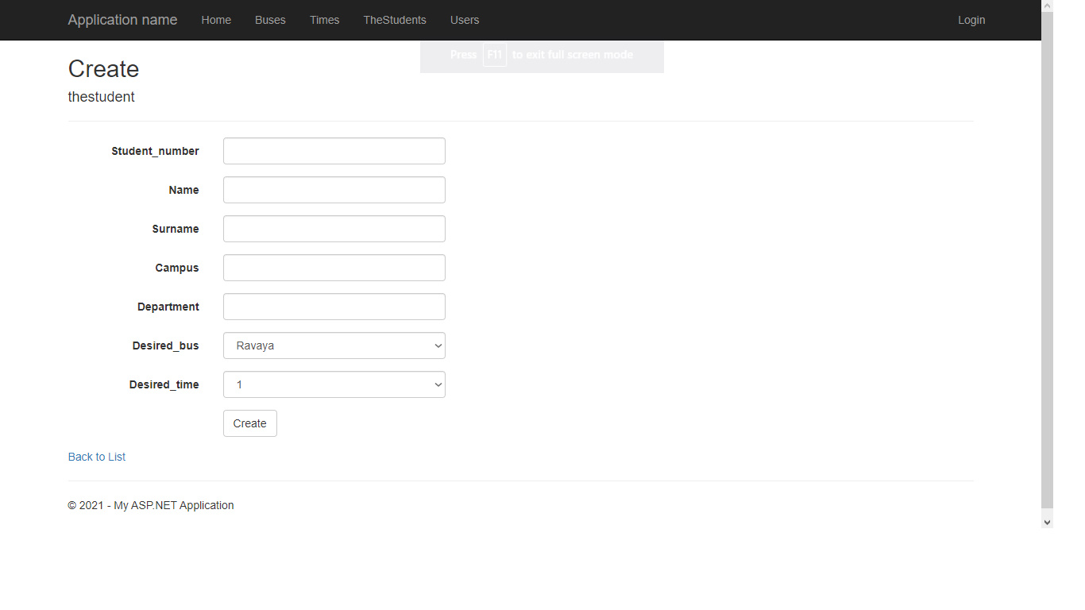This tab is meant for the student and from here they will be able to enter their details then choose which bus they wish to leave with on which date and their space will be reserved. After all the details have been entered, they just have to press ‘Create’ and the entry will be made.

# Edit Data

This tab is meant for the driver and all that must be done is to click on any of the blue labels on the right to Edit or Delete data. To edit data just simply click on where it says ‘Edit’ and you will be redirected to the edit tab.

*The edit data process is the same for all data in the system

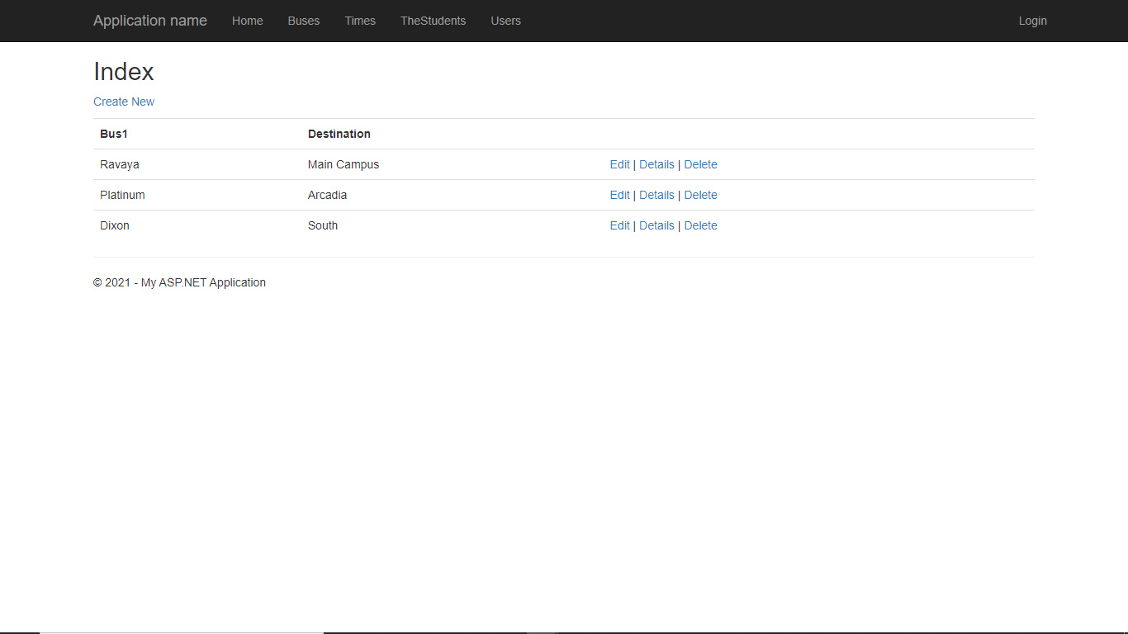

# 

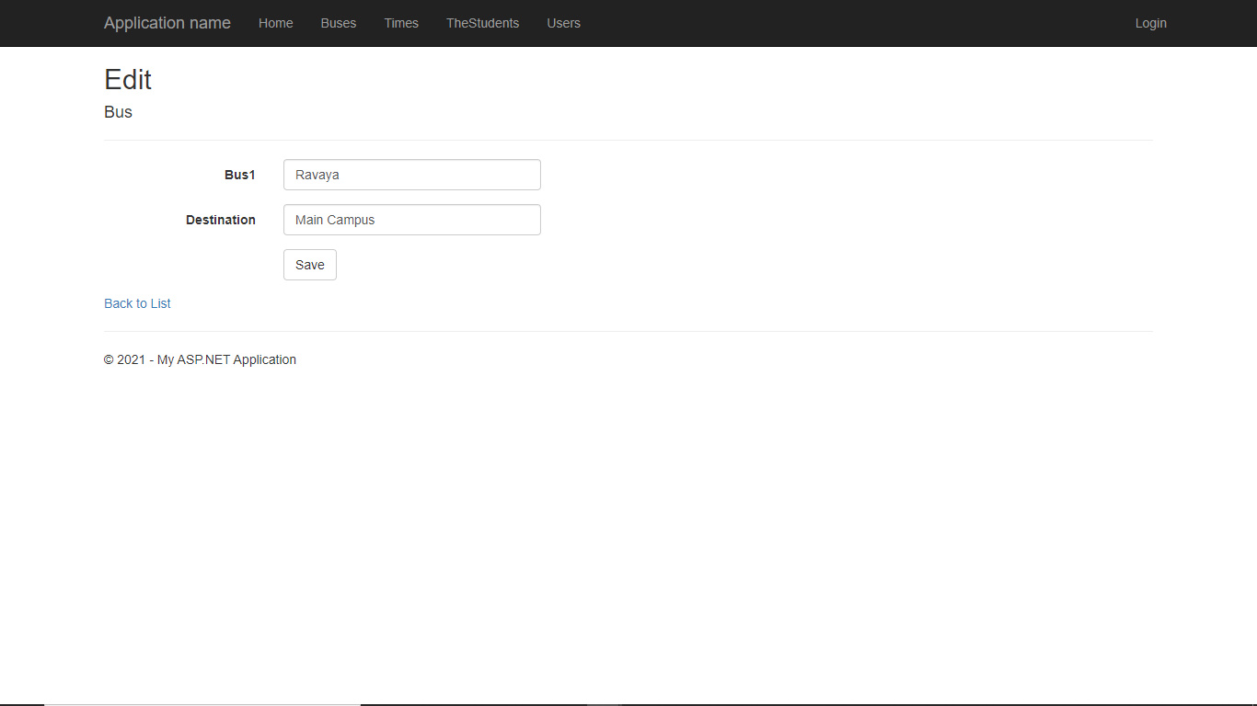To edit data just simply change any information then proceed to click on the ‘Save’ button and you will be redirected back to the list of entries.

# Delete data

In this tab you will be able to delete any record that is no longer needed. To come to this tab simply follow the same process of getting to the Edit tab but instead just press where it said ‘Delete’.

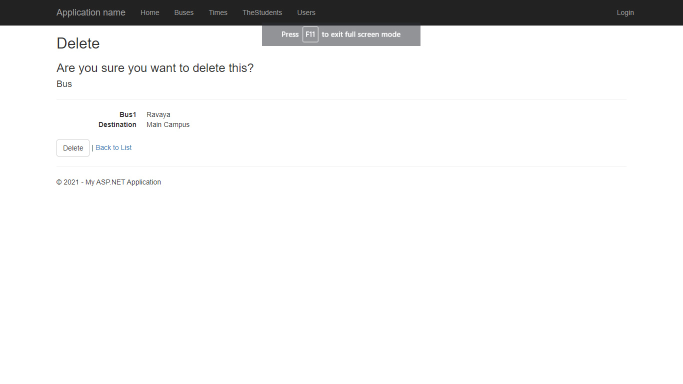*The deletion process is the same for all data in the system